EX. NO.: 19
TITLE
TRIGGER
AIM
To implement trigger in MySQL.
TRIGGER
A trigger or database trigger is a stored program executed automatically to respond to a specific event such as INSERT, UPDATE or DELETE occurring in a table.

PROCEDURE
- Open MySQL Workbench and connect to the MySQL server.
- Select the MobileDB database.
- Create an audit table to store the changes made to the MobileSales table.
- Create a BEFORE UPDATE trigger on the MobileSales table.
- Update a record in the MobileSales table.
- The trigger automatically stores the old values in the audit table.
- Display the audit table using SELECT.
- Observe and verify the result.

COMMANDS
1. Select Database
USE MobileDB;
2. Create Audit Table
CREATE TABLE MobileSales_Audit
(
MobileName VARCHAR(20),
OldPrice INT,
OldCustomerReview DECIMAL(2,1),
OldUnitsSaled INT,
ModelYear INT,
Storage INT
);
3. Create BEFORE UPDATE Trigger
DELIMITER //

CREATE TRIGGER BeforeMobileUpdate
BEFORE UPDATE ON MobileSales
FOR EACH ROW
BEGIN
INSERT INTO MobileSales_Audit
VALUES
(
OLD.MobileName,
OLD.Price,
OLD.CustomerReview,
OLD.UnitsSaled,
OLD.ModelYear,
OLD.Storage
);
END //

DELIMITER ;
4. Display Original MobileSales Data
SELECT * FROM MobileSales;

5. Update a Mobile Record
UPDATE MobileSales
SET Price = 22000
WHERE MobileName = 'MotoG36';

6. Display Audit Table
SELECT * FROM MobileSales_Audit;

7. Check Updated MobileSales Table
SELECT * FROM MobileSales
WHERE MobileName = 'MotoG36';
8. Display Trigger
SHOW TRIGGERS;

OUTPUTS
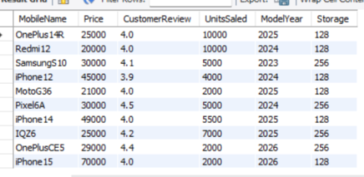

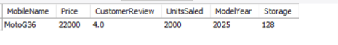
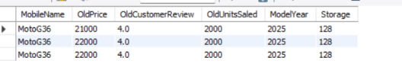

RESULT
Thus the trigger was successfully created and executed in MySQL, and the changes were recorded in the audit table.

